**Name Project: *An application to solve the problem of expatriates*** ***in finding housing inside or outside the university .***

**Project sponsor :Assuit university.**

**Name manager: Barakat Adel Hamdan Youna.**

**Team of project :**

**1 – Barakat Adel Hamdan Younas.(software)**

**2- Khaled Othman Abdelrahem**

**haredy.(software)**

**3- Salah Al-Din Abdel Wakeel Mohamed Hemdan.(software)**

**4- Salem Issa Mohamed Morsy.(software)**

**5-Mohamed Mostafa Talat Abd el-rady(general)**

**6-Mohamed Mahmoud Mohamed Mahmoud(general).**

**7-Mohamed Mostafa Abd el-samie. (general)**

**Purpose of the project :**

**This application helps expatriate students to know the empty places at the university and the places near the university with determining prices and housing features .It saves students time in knowing the places in university housing . Student can book their places from anywhere in the republic after being accepted in the college.**

**Business case :**

**Many expatriate students are not able to attend school because of housing and their lack of knowledge of empty places inside and outside the university .**

**This application helps them to know the largest number of empty places with specifying the address , features and prices , and the students must choose the appropriate for him and book it from anywhere within the country .**

**Tasks :**

**Have three domains ( people – process – Business environment)**

**1 – People domain deals with building leading supporting and promoting a project team .People domain has 14 tasks and 53 enablers.**

**2 – Process domain deals with project governance structure establishment ,Knowledge transfer for project continuity and project phases close out .Process covers project Execution ,Communications ,Risks ,Issues and Change Management .Process domain has 17 tasks and 61 enables .**

**3- Business environment domain covers project compliance Planning & Management and organizational Changing support .Business environment has 4 tasks and 19 enables.**

**Project *scop* :**

**The main goal is to create an application that connects expatriate students and the university and the owners of real estate near the university to know the places , features and prices of housing available at the university or with real estate.**

**This project start on 1\10\2021 and end 30\3\2022.**

**This project must be delivered on 30\3\2022.**

**Key Deliverables:**

**This project helps the students to have sufficient knowledge of the housing and the people’s feedback about them.**

**Project objectives:**

**1-Save time for the students and owners of housing.**

**2-Facilitate student communication with the owners.**

**3-** **Reduce direct contact to maintain public safety.**

**Project Resources :**

**1)Hardware :4 laptops,1 servers.**

**3)Staff : Android developers – IOS developers – back-end developers.**

**Budget :This application will cost to work on this project until its completion 15,000$.**

**Constraints:**

**-The project should not exceed $ 15,000.**

**-Buy any cell phone or any computer from dell**

**-The application area should be small so that expatriates who have weak phones can download it.**

**Assumption :**

**-Anyone working on this project required of him will finish on time.**

**- All important stakeholders will attend the designated meetings.**

**- All team members will complete the project to the end.**

**High level risks:**

**-Incorrectly planning**

**-Data on the project is unclear.**

**-Choosing incorrect technology.**

**-Lack of information protection.**

**WBS**

**1.1**

Beginning

**1.2**

Software and hardware

**1.3**

Test

Coding

**1.4**

The End

|  |
| --- |
| **1.1.1**  **Requirements**  **1.1.2**  **Project Resources** |

|  |
| --- |
| **1.2.1**  Check all hardware  **1.2.2**  Operating system  **1.2.3**  Write coding |

|  |
| --- |
| **1.3.1**  Test function  **1.3.2**  Test Program |

|  |
| --- |
| **1.4.4**  Publish |

Work Breakdown Structure (WBS) dictionary :

BEGINNING :

From 1\10\2021 to 20\10\2021

|  |  |
| --- | --- |
| 1.1.1 | Work package id : |
| Identify Requirement | Work package name: |
| Searching about requires from people and process and Business environment . | Description: |
| Project Manager with team | Person : |
| 1\10\2021 | Start date : |
| 10\10\2021 | End date : |

|  |  |
| --- | --- |
| 1.1.2 | Work package id : |
| Identify resources | Work package name: |
| Searching about require Resources Software and Hardware ( PCs , software , cables …etc ) . | Description: |
| Project Manager with team | Person : |
| 11\10\2021 | Start date : |
| 20\10\2021 | End date : |

1.2 Software and hardware :  
from 21\10\2021 To 20\1\2022

|  |  |
| --- | --- |
| 1.2.1 | Work package id : |
| check the pcs and software &requirement | Work package name: |
| Checking if the software appropriate for PCs , checking if there are problems in cables | Description: |
| Technical | Person : |
| 21\10\2021 | Start date : |
| 10\11\2021 | End date : |

|  |  |
| --- | --- |
| 1.2.2 | Work package id : |
| Check operating system | Work package name: |
| Check all parts of operating system. | Description: |
| Software Engineer | Person : |
| 11\11\2021 | Start date : |
| 30\11\2021 | End date : |

|  |  |
| --- | --- |
| 1.2.3 | Work package id : |
| COODING. | Work package name: |
| Write code using any programming language. | Description: |
| Programmers | Person : |
| 1\12\2021 | Start date : |
| 20\1\2022 | End date : |

1.3 Test coding :

from 21\1\2022 To 10\3\2022 .

|  |  |
| --- | --- |
| 1.3.1 | Work package id : |
| TEST | Work package name: |
| Checking functions that have been coded . | Description: |
| Programmers with Project manager | Person : |
| 21\1\2022 | Start date : |
| 10\2\2022 | End date : |

|  |  |
| --- | --- |
| 1.3.2 | Work package id : |
| TEST and TRAIN | Work package name: |
| Test the program by training groups and take feedback from them | Description: |
| Programmers | Person : |
| 11\2\2022 | Start date : |
| 10\3\2022 | End date : |

1.4 Publish:

from 11\3\2022 To 30 \3\2022

.

|  |  |
| --- | --- |
| 1.4.1 | Work package id : |
| Advertisement | Work package name: |
| Start to Advertise our APP on the internet | Description: |
| Upper management | Person : |
| 11\3\2022 | Start date : |
| 15\3\2022 | End date : |

|  |  |
| --- | --- |
| 1.4.2 | Work package id : |
| LAUNCHING | Work package name: |
| Publish our App on all App stores | Description: |
| Upper management | Person : |
| 16\3\2022 | Start date : |
| 30\3\2022 | End date : |

**Responsibilities Matrix:**

|  |  |  |  |  |  |  |
| --- | --- | --- | --- | --- | --- | --- |
| Task\Member | Project  Manager | Members of Team | Software  Engineer | Programmer | Upper Management | Technical |
| Define Requirements | R | A | C | C | I | C |
| Project Resources | R | A | C |  | I | C |
| Check All Hardware | A | I | R | C | I | R |
| Operating System | A | C | R | I |  | C |
| Write Coding | I | C | A | R | C |  |
| Test Functions | A | I | C | R | I |  |
| Test Program | A |  | C | R | I |  |
| Publish | A | I | C | C | R | C |

**RACI:**

- Responsible: Person who is completing the task.- Accountable: Person who is making decisions and taking actions on the task(s).- Consulted: Person who will be communicated with regarding the decision-making process and specific tasks.- Informed: Person who will be updated on decisions and actions during the project.

**Network Information :**

|  |  |  |  |
| --- | --- | --- | --- |
| ACTIVITY | DESCREPTION | PRECEDING ACTIVITY | ACTIVITY TIME |
| A | DEFINE REQUIREMENT | NONE | 10 WORKDAYS |
| B | PROJECT RESOURCES | A | 10 |
| C | CHECK ALL HARDWARE | A | 20 |
| D | OPERATING SYSTEM | B | 20 |
| E | WRITE CODING | C | 50 |
| F | TEST FUNCTIONS | C | 20 |
| G | TEST PROGRAM | D | 30 |
| H | PUBLISH | E,F,G | 20 |

**Project Network:**

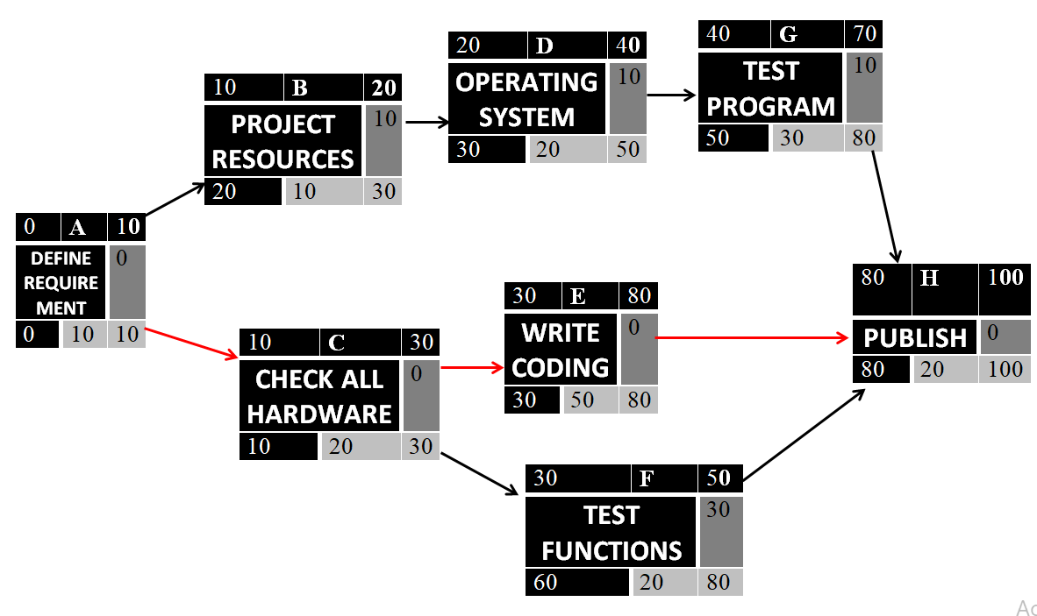

**Critical Path: A,C,E,H**

**Project Gantt Chart:**

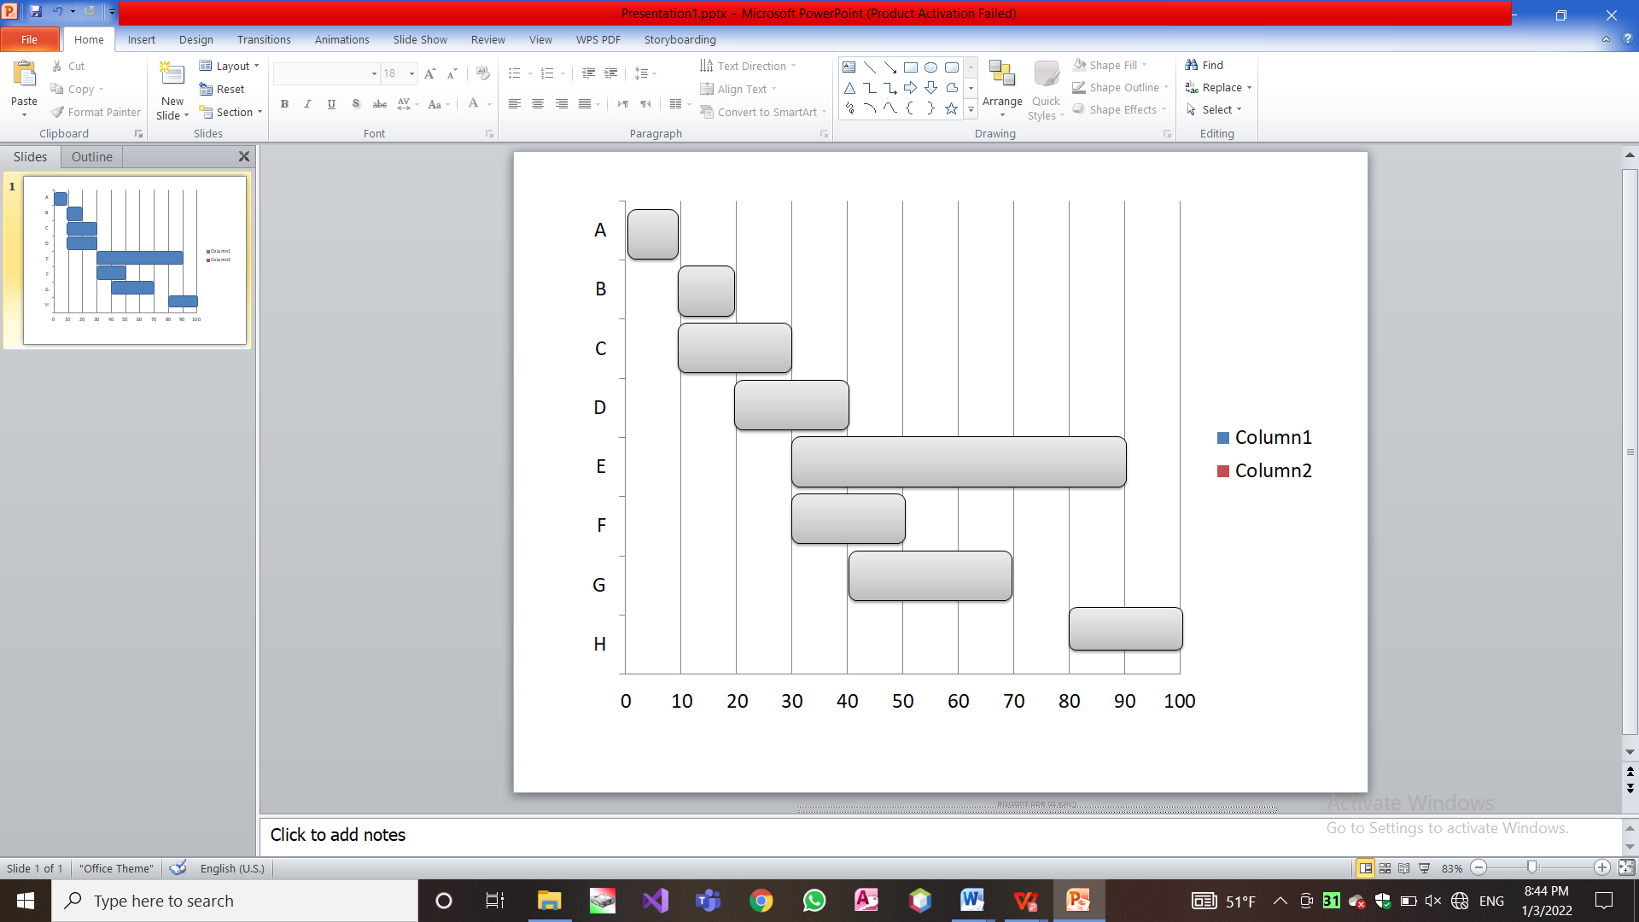

**Resource Scheduled Network:**

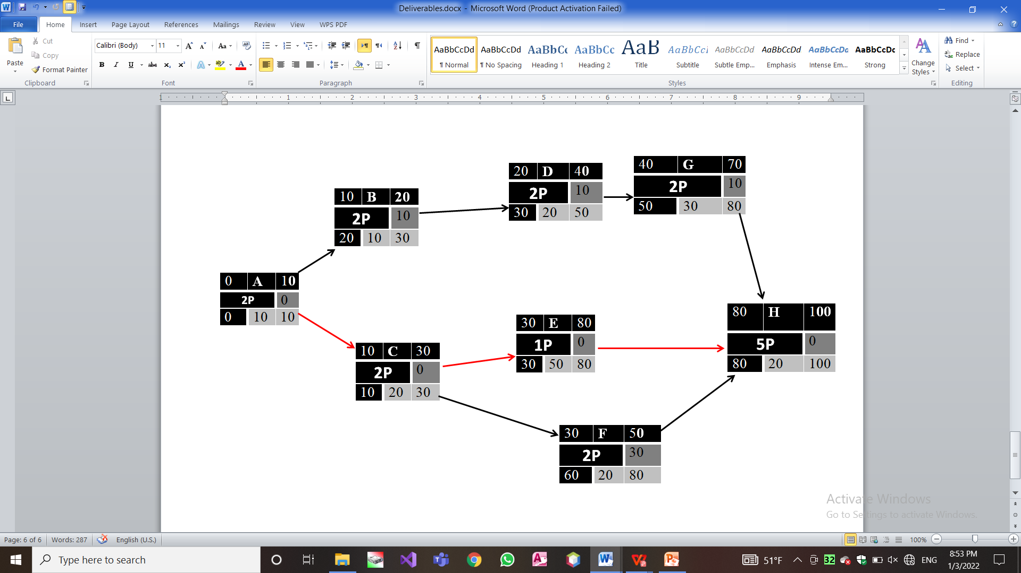

**Resource-Constrained Schedule:**

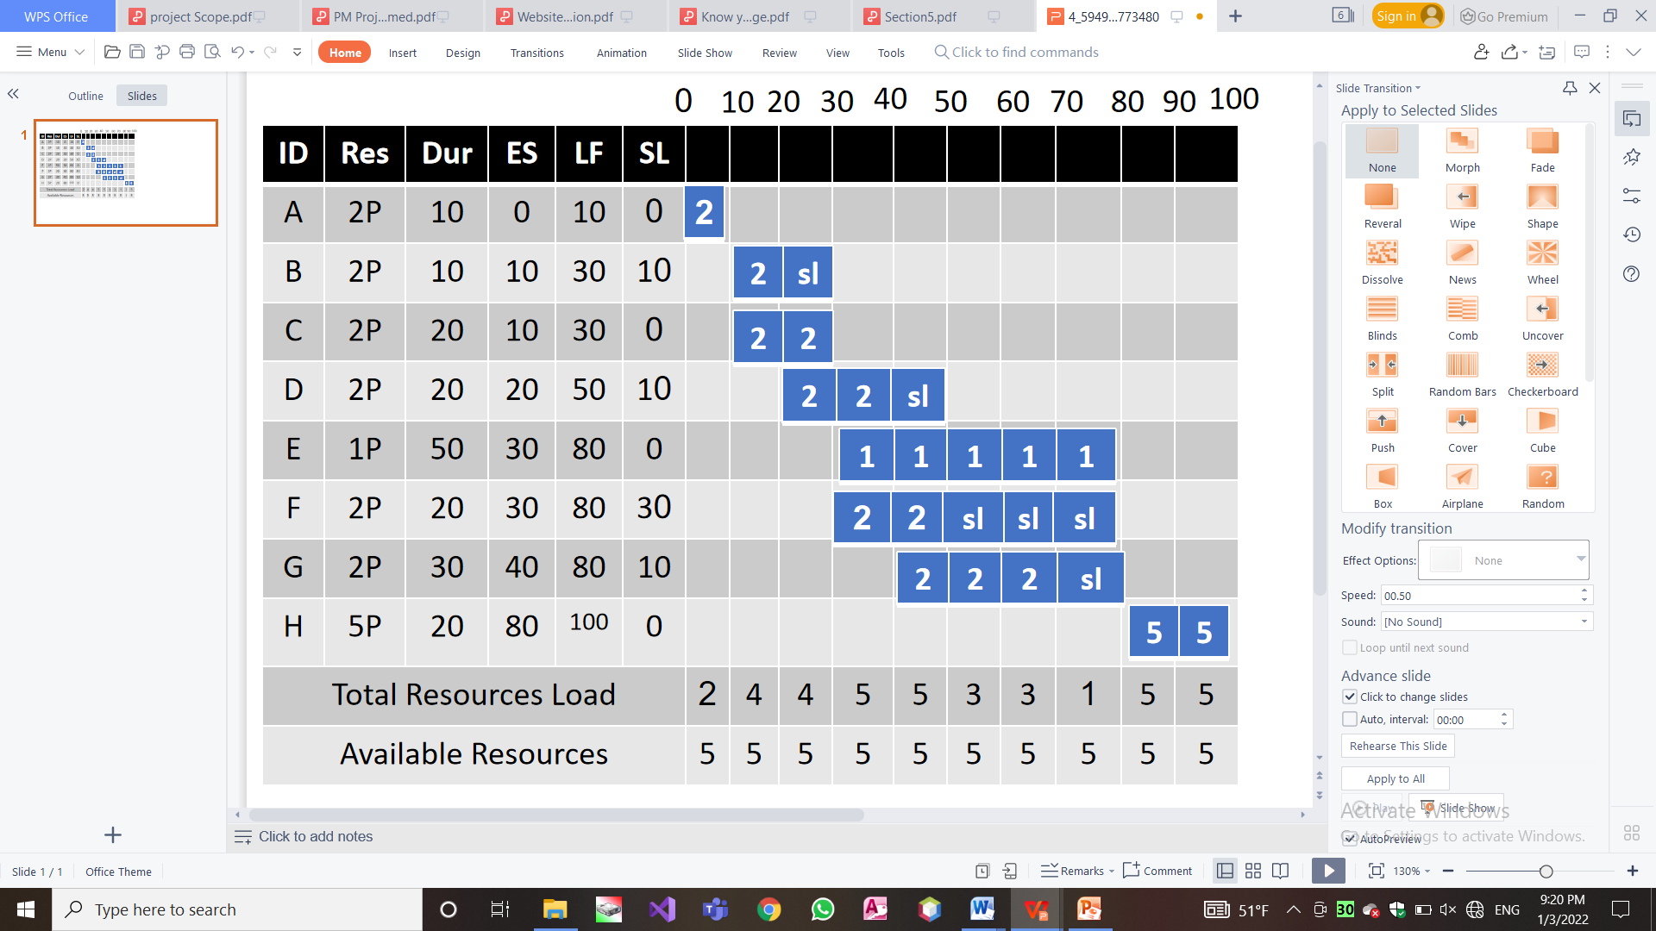

**Time-Phased Work Packages:**

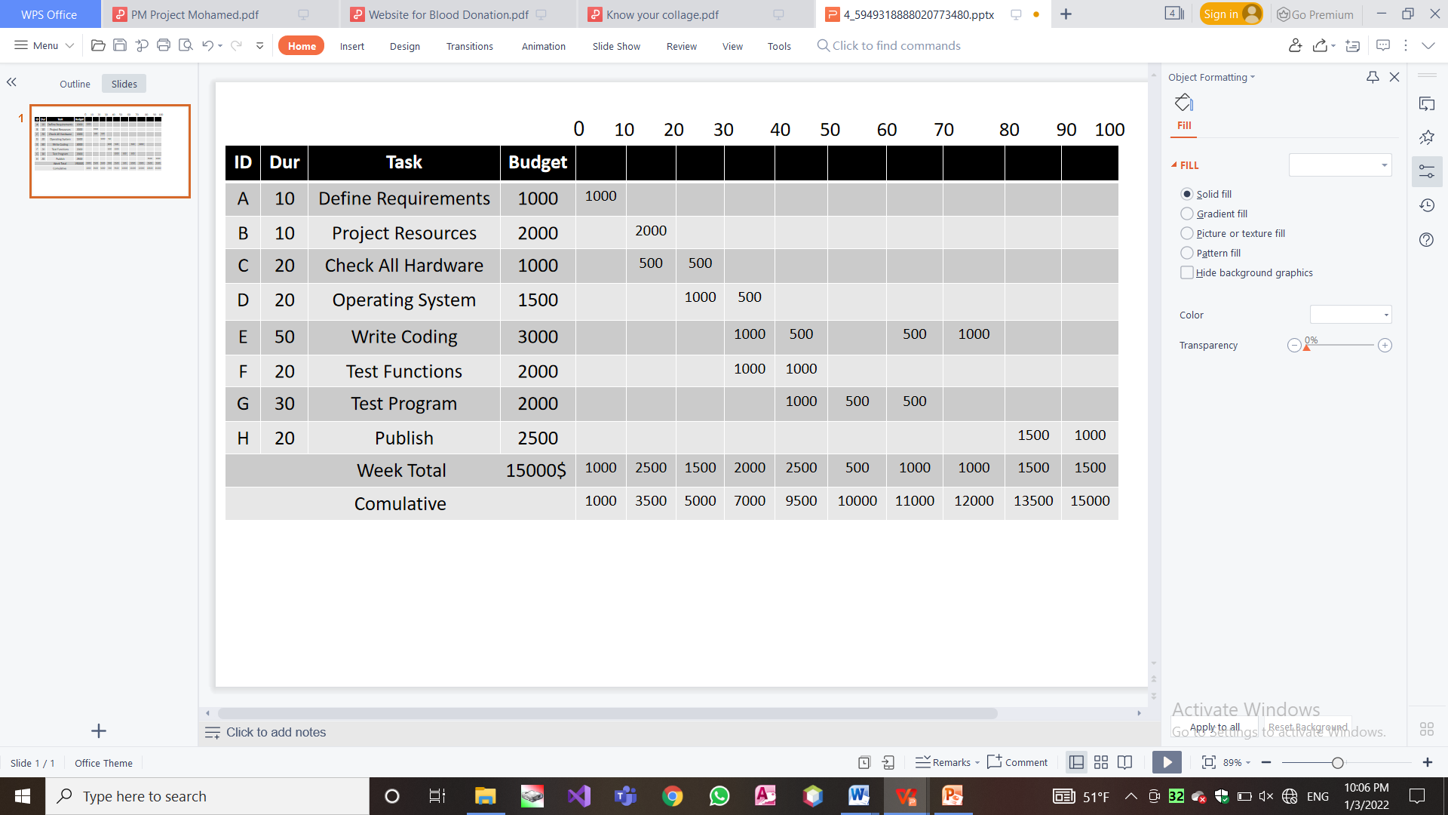

**Cumulative Baseline Budget(PV):**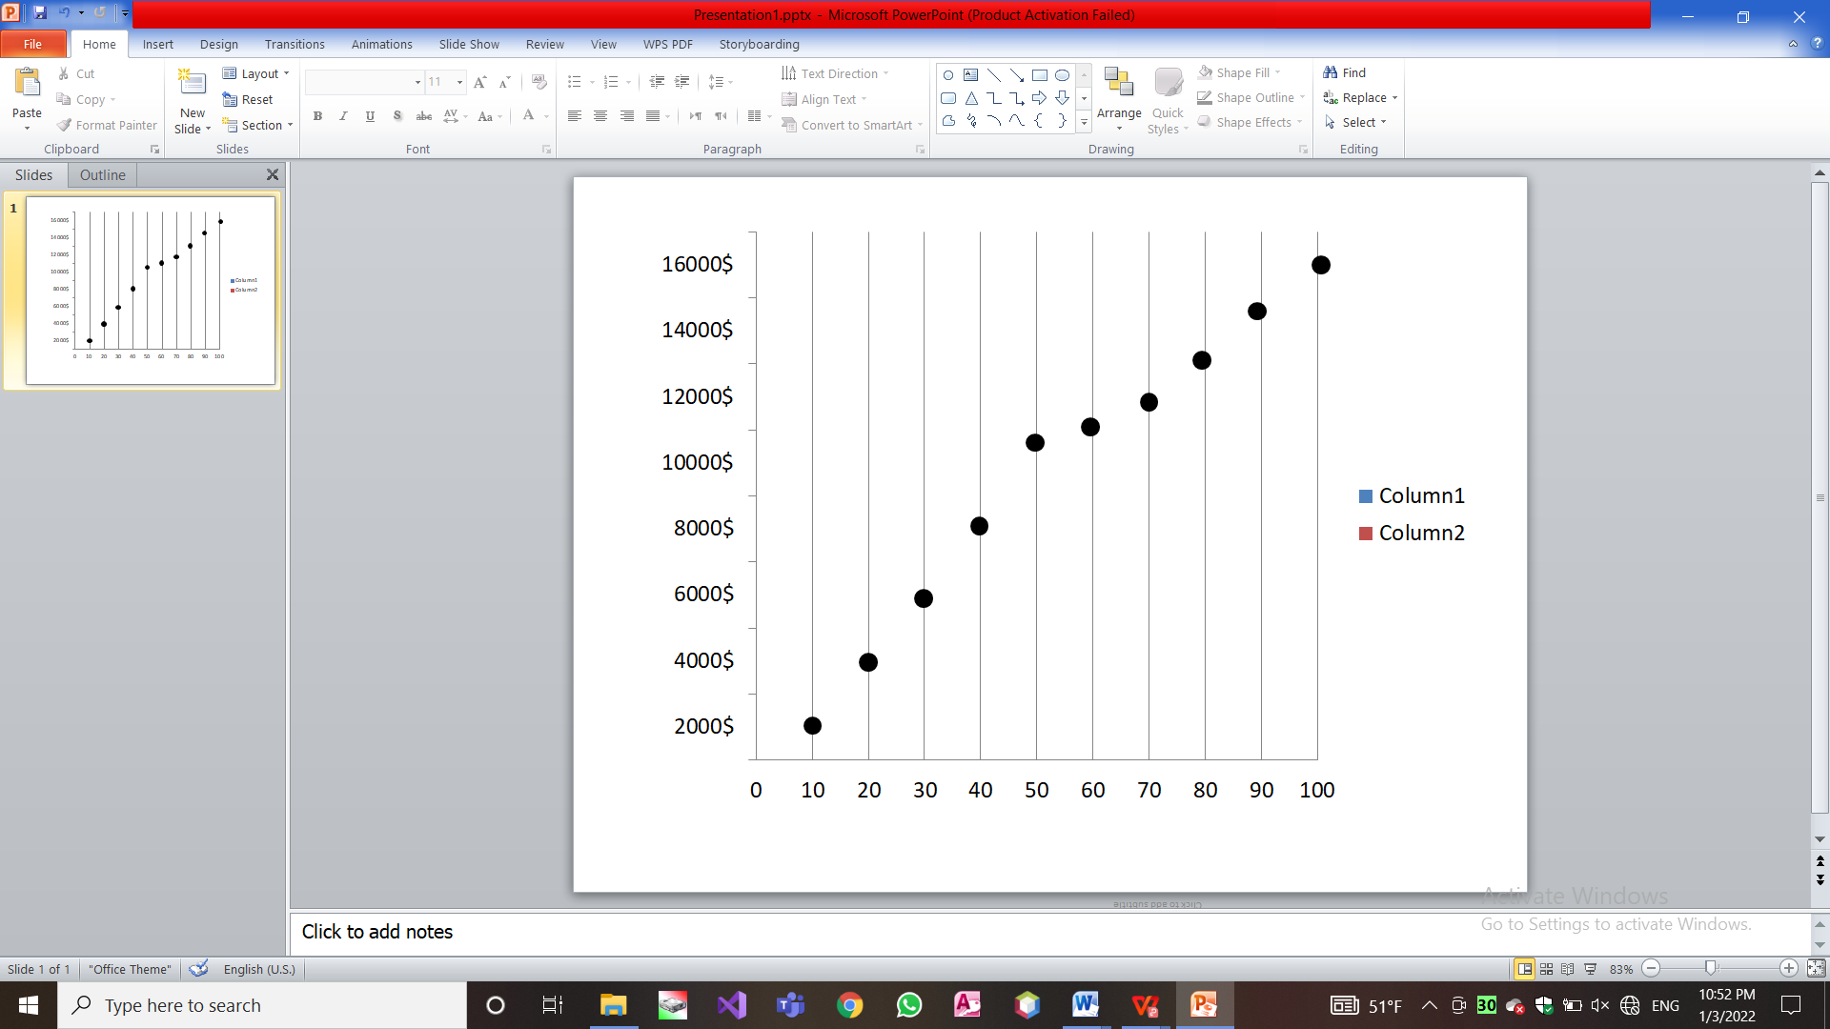

**Risk management:**

|  |  |  |
| --- | --- | --- |
| **Solutions** | **Sub causes** | **Main causes** |
| ensuring the team_members and taking the feedbace of customers in every step. | 1)the time for the project was initially incorrectly calculated and set  2) the project manager does not properly track employees  3) lack of resources | **a) Bad use of time** |
| Determine the budget for each task from the beginning | 1) the budget was initially calculated incorrectly.  2) unplanned project expansion. | **b) Incorrect budget estimation** |
| The project manager must be in constanat contact with the members and have leadership qualities. | 1)Poor communication between manager and members.  2)Poor communication between members and each other.  3)lack of leadership and analytical skills. | **c) Weak management** |
| Choosing professional cadres capable of doing this task | 1) too complex multi-part project.  2) lack of professionalism and knowledge of team members  3) changes in software requirements | **d) Weakness of coding** |
| Maintain up-to-date documentation.  On board new or replacement stakeholders with a learning guide | Though unlikely, occasionally a stakeholder or development team member must leave a project unexpectedly | **e)Few human resourses** |